Wuthering Heights
A novel by EMILY BRONTË

Group Members: Alisha Negrón, Daymara Deynes, Nahir I.C. Robles, Karen M. Montes, Pedro Díaz and Jonathan Medina.
Author: Emily Jane Brontë
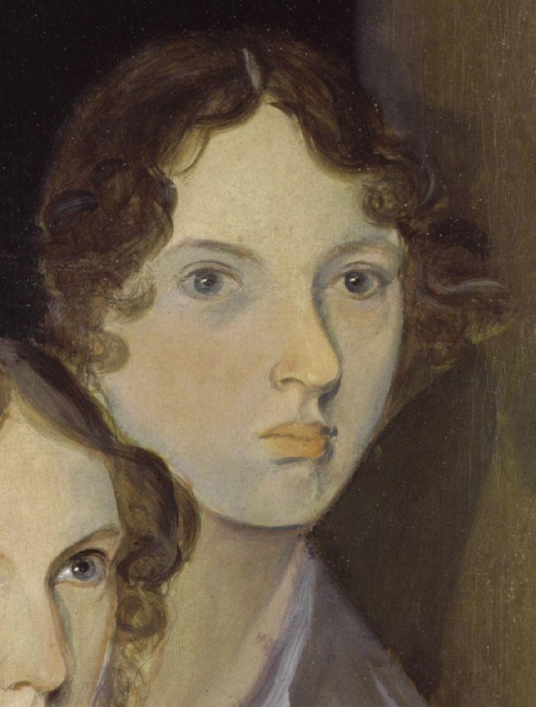
Emily Jane Brontë was born on 30 July 1818 in the North of England to Maria Branwell and Patrick Bronte. She was the younger sister of Charlotte Bronte and the fifth of six children. The children began to write fiction at home. When Emily was 13 she and Anne her sister withdrew for participation in the Angria story and began a new one about Gondal a fictional island whose myths and legends were to preoccupy the 2 sisters thought their lives.

At 17 Emily attended the Roe Head girl’s school where Charlotte was a teacher, but she stays only a few months before being overcome by extreme homesickness. She returned home and Anne took her place. In 1838 when she was 20 Emily became a teacher at Law Hill School in Halifax.

In 1842 Emily accompanied Charlotte to the Héger Pensionnat in Brussels, Belgium, where they attended the girl’s academy run by Constantin Héger. They planned to perfect their French and German in anticipation of opening their school. Nine of Emily’s French essays survive from this period. In 1844, Emily began going through all the poems she had written, recopying them neatly into two notebooks. One was labeled “Gondal Poems” the other was unlabeled. One year later Charlotte discovered the notebooks and insisted that the poems be published. Emily furious at the invasion of her privacy at first refused but relented when Anne brought out her own manuscripts. In 1846, the sisters poems where published, Emily contributed with 21 poems.

In 1847 Emily Bronte’s Wuthering Heights was published. Emily’s real name didn’t appear until 1850.Wuthering Heights violence and passion led the Victorian public and many early reviewers think that it had been written by a man. Although a letter a letter of her publisher indicates that Emily had begun to write a second novel, the manuscript has never been found. Emily Bronte dies in December 1848 at age of 30.

- Personality
About her personality Emily remains a mysterious figure because her information is sparse. She does not seem to make any friends outside her family. Emily’s unsociability and extremely shy nature has subsequently been reported many times. In Queens of literature of the Victorian Era (1886), Eva Hope summarizes Emily’s character as “a peculiar mixture of timidity and Spartan- like courage” and goes on to say “She was painfully shy, but physically she was brave to surprising degree.

Historical Context
Wuthering Heights takes place across different points of late 17th century and early 18th century. First we should note that Great Britain went through the second Jacobite rebellion in 1745, as this begins to outline that Great Britain is indeed in its hay day. British empiricism is at its strongest and the recent success in wars and commerce has left its residents with a great sense of self-worth. “After 1760, a gradual but continuing rise in the rates of industrial and economic growth led to Britain becoming the world's first industrial nation.”(Morgan). The novel itself starts in 1771, when Heathcliff is brought into the household. About 5 years later, the American Revolution begins, but we observe a sort of calmness in the environment of the plot. Wuthering Heights and the world around it seems almost untouched by all the war time madness that’s happening. The plot carries on into the early 1800’s, all the while Britain is entering a sort of state of convalescence. It’s focusing on itself, exerting control over its colonies and thereafter entering the industrial age. We don’t really perceive any of that in the novel though. We don’t really perceive the start of the French revolution in 1789 either, bar a small mention in a newsletter.

Themes in the movie
In Wuthering Heights, there are a lot of themes presented. The first theme itself, which is the one that makes this play, is the destructiveness of love as we see in Cathy and Heathcliff’s relationship. It is a love that has been going on since their childhood. It is criticized by Nelly, because of its immoral roots, but it is a feeling that maintains until the death of Cathy. It is destructive because Cathy chose to marry Edgar, in order to have a gentle life, even though she did not love him. It was convenience over true love. Heathcliff said he was going to vengeance his lover’s tragic death, by ruining the future generation. But behind the tragic story finale of Heathcliff and Cathy, booms another romantic story: Catherine and Hareton. These two are the ones who put Wuthering Heights and The Grange back to place. Hareton is the son of Hindley and his wife Frances, while Catherine is the daughter of Edgar and Cathy. Both are the result of the wrath between these two families. There is another character involved: Linton, who is the son of Edgar’s sister, Isabella, and Heathcliff. These three characters are used for Heathcliff’s revenge. The second theme is about finding themselves. Cathy says the infamous phrase: “I am Heathcliff.” Suggesting one is part if the other.
Critiques
Wuthering Heights was published in December 1847 under the pseudonym of “Ellis Bell” so contemporary reviewers believed it was written by a man. Not only that but many believed it was written by Currer Bell (Charlotte Bronte), author of the instant success Jane Eyre. The novel received mixed reception but they all agreed in one thing: the book left a powerful impression. Here are some reviews of the novel by contemporaries of the time.
- “Wuthering Heights is a strange sort of book,—baffling all regular criticism; yet, it is impossible to begin and not finish it; and quite as impossible to lay it aside afterwards and say nothing about it. In the midst of the reader's perplexity the ideas predominant in his mind concerning this book are likely to be—brutal cruelty, and semi-savage love… We strongly recommend all our readers who love novelty to get this story, for we can promise them that they never have read anything like it before.“ - Douglas Jerrold’s Weekly Newspaper, 1848.
- “We are not quite sure that the next new novel will not efface it, but Jane Eyre and Wuthering Heights are not things to be forgotten. The work of Currer Bell is a great performance; that of Ellis Bell is only a promise, but it is a colossal one.” – Atlas, 1848.
- “How a human being could have attempted such a book as the present without committing suicide before he had finished a dozen chapters, is a mystery. It is a compound of vulgar depravity and unnatural horrors…” – Graham’s Lady’s Magazine, 1848.
In 1850, Charlotte edited the works of her sisters, and added a Biographical Notice in which she gives details of her sisters and herself. Influenced by Charlotte’s introduction and moved by pity for Emily’s and Anne’s deaths, the critics were less harsh. This time critics had a better understanding of Emily’s achievements, which was even compared to Shakespeare.
Later in the 20th century, critics began to place Emily’s Wuthering Heights above Charlotte’s Jane Eyre. The structure of the novel is still a topic of argument between critics. The fact is the Wuthering Height is now considered one of the masterpieces of the nineteenth-century fiction. Here are a couple of later critical responses to Wuthering Heights.
- “It is one of the most carefully constructed novels in English.” – Mark Schorer
- “A splendid, imperfect novel which Brontë loses control over occasionally.” -Albert J. Guerard
Social Aspects (to be discussed in classroom)
- Social discrimination against women
- Inheritance
- Masculine hierarchy
- Marriage at young age
- Religion
- Racism (economic, social, color)
- Love vs. Money
Elements of Growing Up of Age
Coming of age is the transition from childhood to adulthood, as we all know. In this story we can see the coming of age of Heathcliff, Catherine and Hareton.

Heathcliff – Heathcliff was alone and adopted by Mr. Earnshaw. At first, Catherine and Heathcliff were friends, they had a lot of fun together as kids, but as they grew up they fell in love, which is part of coming of age. When Catherine started to change, he decided to leave. He came back after Catherine’s marriage and he was a completely different man. He still hated people, but he learned how the world works and how to take advantage of “the man’s weakness” as he mentioned, to get money and move up in the world. This can also be considered as coming of age, he didn’t exactly become a nicer person but he learned to be a very mean adult.

Catherine – As Heathcliff, you can also notice her coming of age as she fell in love with Heathcliff. But another important step was when she stayed with Mr. Linton. The moment her leg got hurt and was forced to stay at Mr. Linton’s house, Hindley knew she had to stay so she can be a cult woman and to start acting “ladylike”. In the end it worked, she wasn’t the wild girl Heathcliff loved, she became a lady but she started to push Heathcliff aside and when Mr. Linton asked her to marry her, she couldn’t give an answer straight away. She loved Heathcliff, sadly she chose too late, which is another part of being an adult; we have to make our choices, and sometimes there is a time limit. When she knew what she wanted, Heathcliff was already on a horse running away.

Hareton – It isn’t exactly clear about his coming of age, but you can see him when he’s a child running around the place, and Hindley trying to scold him. When he started living with Heathcliff, he changed and was a more obedient man. He would do anything for Heathcliff, despite him being a cruel man, since he “owed” him everything. In the end he started to love Catherine, the daughter.

Bibliography

- Luscombe, Stephen. "British Empire: Eighteenth Century Timeline." British Empire: Eighteenth Century Timeline. N.p., n.d. Web. 8 Oct. 2013.
- Morgan, Kenneth. "Overview: Empire and Sea Power, 1714 - 1837." BBC News. BBC, n.d. Web. 09 Oct. 2013.
- “The Reader’s Guide to Emily Brontë’s “Wuthering Heights”. www.wuthering-heights.co.uk. 2007. Web. 6 October, 2013.
- Wuthering Heights by Emily Bronte Talking (book)shop: An unconventional book review. Web. 7 October, 2013

